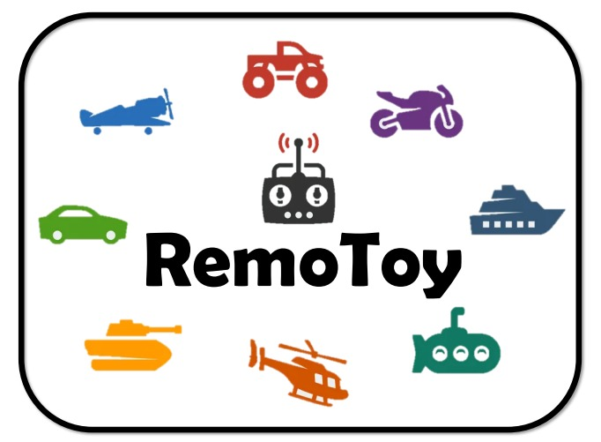
Project Charter
RemoToy
- Frank Lampard
- Steven Gerrard
- Gary Lineker
- David Beckham
- George Best

MGMT-3105 Group 2 27 October 2024

